**REVENUE ANALYSIS REPORT FOR LEE’S SANDWICHES STORES AT BAY AREA IN 2017**

**1. Overview:**

Lee’s Sandwiches, a Vietnamese fast food chain, is well-known with the combination between Vietnamese sandwiches and European-style baguette sandwiches.

Lee’s Sandwiches is currently attracting a diverse crowd in all ethnicities of all ages with the extensive menu. Especially, Lee’s Sandwiches had been becoming more and more popular in Bay Area, where very first Lee’s stores were born. With the arm to serve more and more people in community, this Vietnamese style bakery franchise is currently growing with a high speed and will be potentially expanded across the country in the future.

**2. Empirical analysis**

As in 2017, Lee’s Sandwiches had owned 15 stores around the Bay Area. This analysis report focuses on analyzing sale performance of 13 typical stores among those to help orienting Lee’s Sandwiches corporation grow prosperously in the future.

**Figure 1: Revenue comparison among 13 Lee’s Sandwiches Stores around Bay Area 2017**

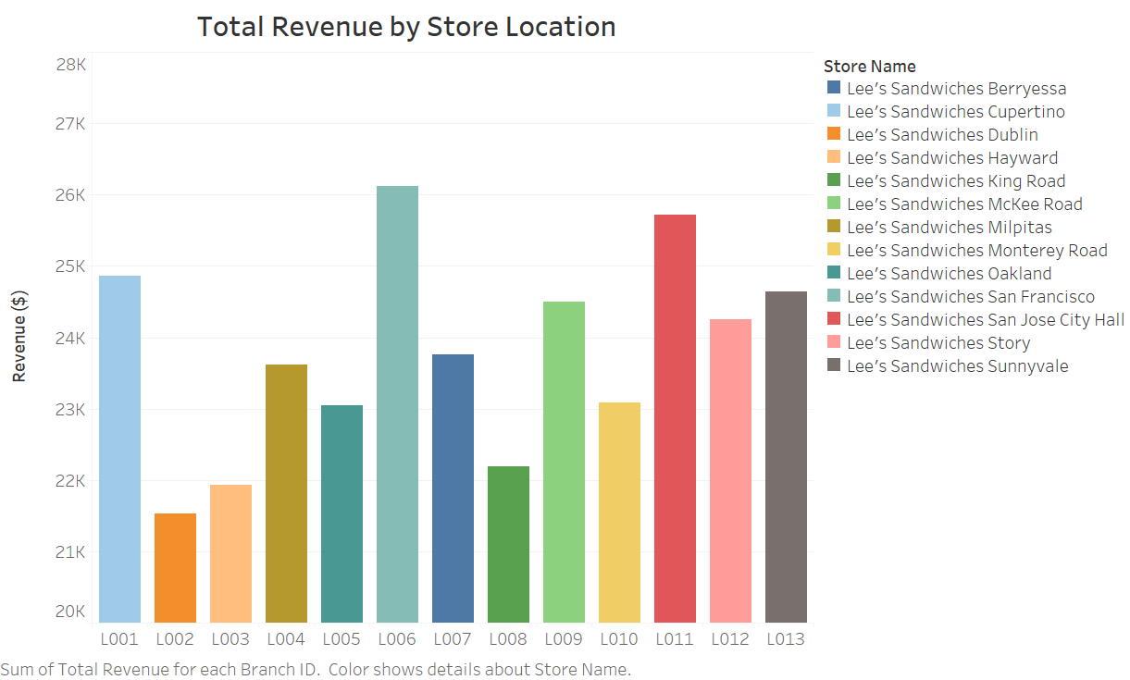

No surprises, two main Lee’s stores located at San Francisco and Downtown San Jose received the highest revenue in all 13 stores located in Bay Area. These areas are attracting a vast of customers around to visit and purchase. Lee’s should consider improving customer services here to keep and maintain the number of current customers visit as well as attract to increase potential customers.

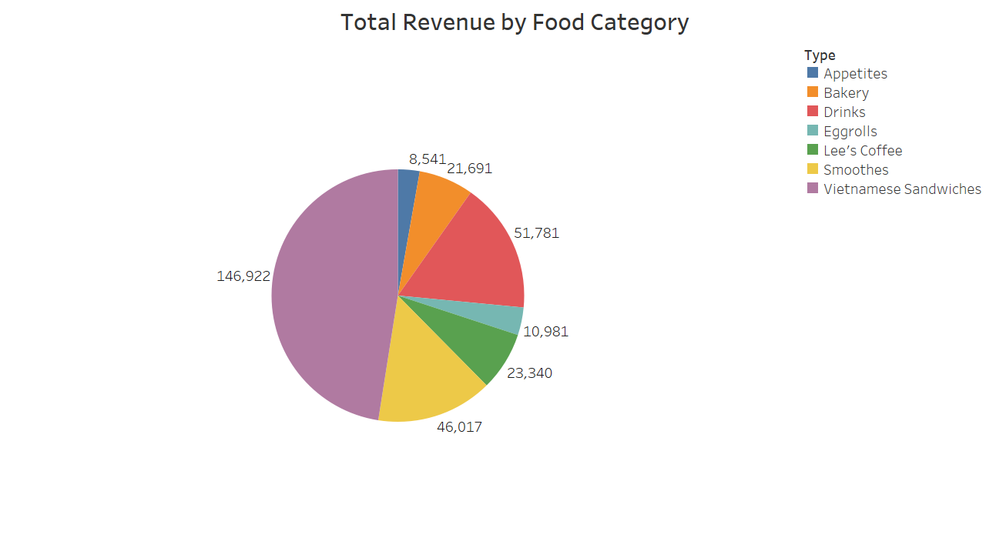**Figure 2: Revenue proportion among Lee’s products in 2017**

Let look at sales of Lee’s products in 2017. Vietnamese Sandwiches took over nearly 50% of revenue of Lee’s product sales, following with general Drinks and Smoothies. Of course, if Lee’s want to diverse its products, it should consider introducing new items among these categories. Eggrolls and Appetites are those items that the least people was interested in.

**Figure 3: Revenue trending in 2017**

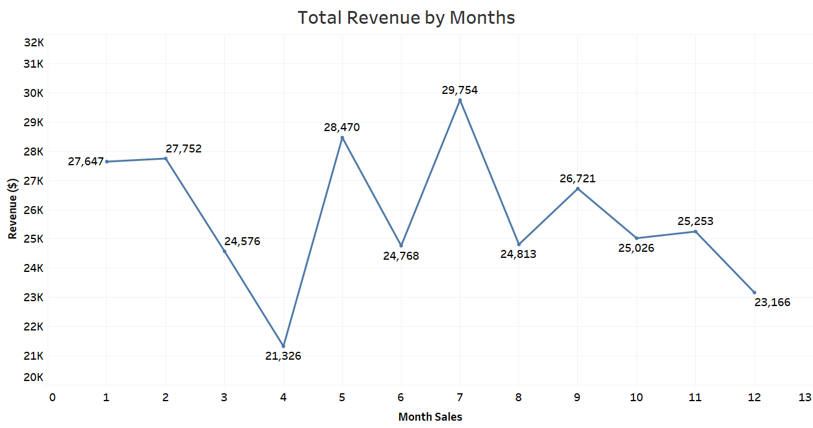

Another aspect of analyzing Lee’s sales is examining sales performance by months, explore seasonal sales to develop appropriate strategies. It seems that sales performance significantly fluctuated from May to September. The lowest revenue was in April and the highest revenue was in July. That should be wise if Lee’s expands its business during Summer and Fall.

***Software used:***

**SSMS (Microsoft SQL Server Management Studio) – Excel** **– Tableau**